|  |
| --- |
|  |
| 新概念 3 册 |
| Lesson10 The loss of the Titanic |

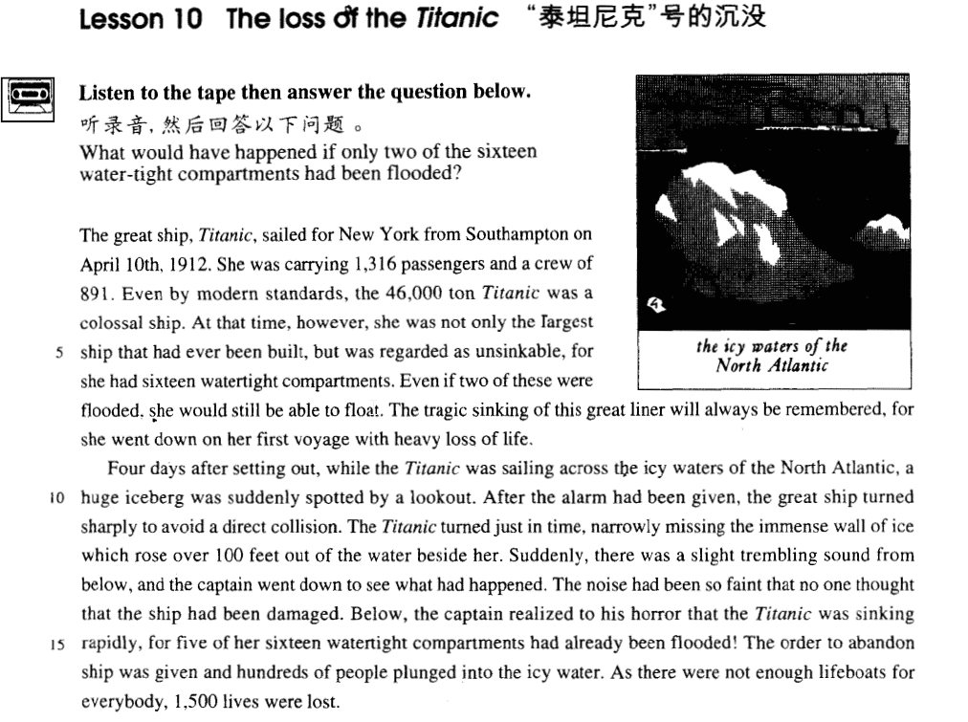

课文

The great ship, Titanic sailed for New York from Southampton on April 10th, 1912.

巨轮“泰坦尼克”号1912年4月10日从南安普敦起锚驶向纽约。

She was carrying 1,316 passengers and a crew of 891.

船上载有1,316名乘客与891名船员。

Even by modern standards, the 46,000 ton Titanic was a colossal ship.

却使用现代标准来衡量，45,000 吨的“泰坦尼克”号与算得上一艘巨轮了。

At that time, however, she was not only the largest ship that had ever been built, but was regarded as unsinkable, for she had 16 water-tight compartments.

当时，这艘轮船不仅是造船史上建造的最大的一艘船，而且也被认为是不会沉没的。因为船由16个密封舱组成，

Even if two of these were flooded, she would still be able to float.

即使有两个舱进水，仍可漂浮的水面上。

The tragic sinking of this great liner will always be remembered, for she went down on her first voyage with heavy loss of life.

然而，这艘巨轮首航就下沉，造成大批人员死亡。人们将永远记着这艘巨轮的沉没惨剧。

Four days after setting out, while the Titanic was sailing across the icy waters of the North Atlantic,

“泰坦尼克”起航后的第4天，它正行驶在北大西洋冰冷的海面上。

a huge iceberg was suddenly spotted by a lookout.

突然，了望员发现一座冰山。

After the alarm had been given, the great ship turned sharply to avoid a direct collision.

警报响过不久，巨轮急转弯，以避免与冰山正面相撞。

The Titanic turned just in time, narrowly missing the immense wall of ice which rose over 100 feet out of the water beside her.

“泰坦尼克”这个弯拐得及时，紧贴着高出海面100英尺的巨大的冰墙擦过去。

Suddenly, there was a slight trembling sound from below, and the captain went down to see what had happened.

突然，从船舱下部传来一声微颤音，船长走下船舱去查看究竟。

The noise had been so faint that no one thought that the ship had been damaged.

由于这个声音非常轻，没人会想到船身已遭损坏。

Below, the captain realized to his horror that the Titanic was sinking rapidly,

在下面，船长惊恐的地发现“泰坦尼克”号正在急速下沉，

for five of her sixteen watertight compartments had already been flooded!

16个密封舱已有5个进水。

The order to abandon ship was given and hundreds of people plunged into the icy water.

于是，他发出弃船的命令，几百人跳进了冰冷刺骨的海水里。

As there were not enough life-boats for everybody, 1500 lives were lost.

由于没有足够的救生艇运载所有乘客，结果，1,500 人丧生。

词汇讲解

* **colossal [kə'lɔsl]** adj. 巨大的，庞大的
* a colossal ship
* a colossal sum of money

表示“巨大的”的单词

**huge *adj.*** 巨大的；庞大的；无限的

**great *adj.*** 伟大的，重大的；极好的，好的；主要的

**immense *adj.*** 巨大的，广大的；无边无际的；非常好的

**enormous *adj.*** 庞大的，巨大的；凶暴的，极恶的

**gigantic *adj.*** 巨大的，庞大的

**titanic *adj.*** 巨大的；(同时还强调坚固的)

* the Titans



* **watertight ['wɔ:tətaɪt]** adj. 不漏水的

**watertight *adj.*** 水密的；不漏水的；无懈可击的

**waterproof *adj.*** 防水的，不透水的

**airtight *adj.*** 密闭的，密封的；无懈可击的

**hermetic *adj.*** 密封的；与外界隔绝的；不透气的；炼金术的

**sealed *adj.*** 密封的；未知的

* The teacher opened the sealed envelope containing the exam papers.
* **tragic** ['trædʒik] adj. 悲剧的，悲惨的

tragedy ***n.*** 悲剧；灾难；惨案

tragic ***adj.*** 悲剧的；悲痛的，不幸的

comedy ***n.*** 喜剧；喜剧性；有趣的事情

comic ***adj.*** 喜剧的；滑稽的；有趣的

drama ***n.*** 戏剧，戏剧艺术；剧本；戏剧性事件

dramatic ***adj.*** 戏剧的；急剧的；引人注目的；激动人心的

* **liner** ['laɪnə(r)] n. 班轮

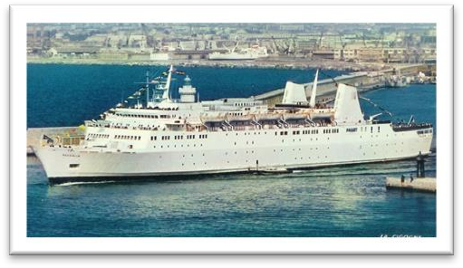(ocean) liner

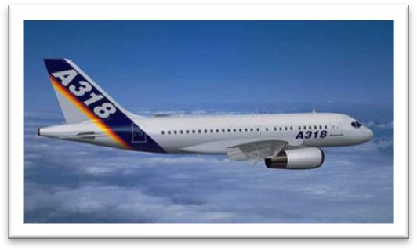 **air liner** ***na.*** 客机

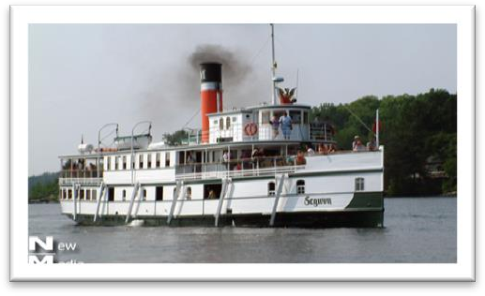 **steamship *n.*** 轮船；汽船

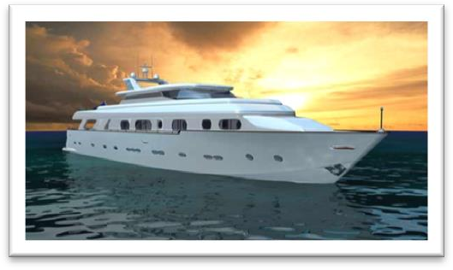**yacht *n.*** 游艇，快艇；轻舟

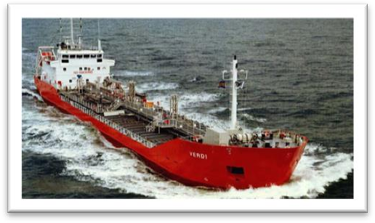 **tanker *n.*** 油轮；运油飞机；油槽车；坦克手

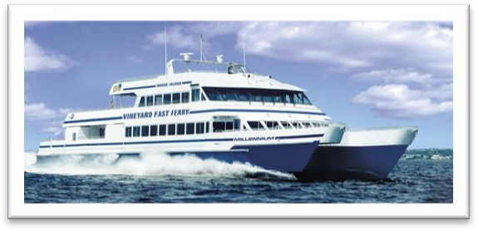 **ferry *n.*** 渡船；摆渡；渡口

 **raft *n.*** 筏；救生艇；

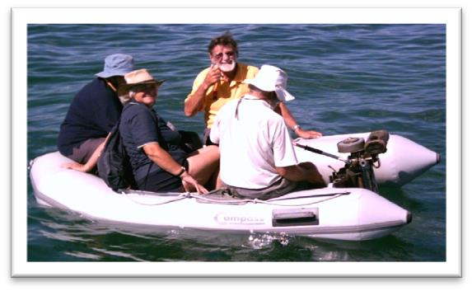 **dinghy *n.*** 小艇；小船

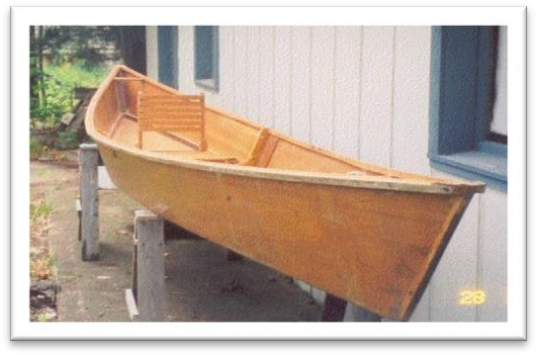 **canoe *n.*** 独木舟；轻舟

 **kayak *n.*** 皮船；爱斯基摩小艇

* **voyage** ['vɔɪɪdʒ] n. 航行

voyage ***n.*** 航行(海上)

flight ***n.*** 航行(空中)

**navigation *n.*** 航行；航海

**aviation *n.*** 航空；

be on a **voyage / flight / trip / journey / tour** President Trump is on a five-nation tour.

Bon voyage! 一路顺风

Have a good trip!

Happy landings!

* **narrowly ['nærəʊli]** adv. 刚刚，勉强
* We won **narrowly**. 勉强赢了
* He **narrowly** escaped drowning. 勉强逃掉

**(only) just** ***na.*** 好容易；刚刚才；恰好

* She **(only) just** failed in the exam. 没及格

表示”几乎不…,勉强…”

hardly ***adv.*** 几乎不，简直不；刚刚

scarcely ***adv.*** 几乎不，简直不；简直没有

barely ***adv.*** 仅仅，勉强；几乎不；

* I hardly know him.
* tremble ['trembl] v. 震颤，颤抖
* He **trembled** with anger. (指人)
* The leaves **trembled** in the breeze. (指物)

**quiver** ***vi.*** 颤抖；振动 ***vt.*** 使…颤动；抖动

**shiver** ***vi.*** 颤抖；哆嗦；打碎 ***vt.*** 颤抖；打碎

* When I kiss your lips, ooh I start to **shiver**, Can’t control the **quivering** inside. Wouldn’t you agree, baby you and me got a groovy kind of love. —Phil Collins

**shudder** ***vi.*** 发抖；战栗 (剧烈的颤抖)

* … make a modern climber **shudder** at the thought, …
* **horror** ['hɒrə(r)] n. 惊恐 ***n.*** 惊骇；惨状；极端厌恶；令人恐怖的事物

**horror** n. feelings of great fear and shock (侧重指因看到令人讨厌或危险的东西或情景而引起的厌恶情绪、极度恐惧心情或战栗的动作。)

terror n. extreme fear 极度震惊 (指极大的恐惧和惊骇，语气最强。)

horrify ***vt.*** 使恐惧；惊骇；使极度厌恶

horrifying ***adj.*** 令人恐惧的；使人惊骇的

terrify ***vt.*** 恐吓；使恐怖；使害怕 (语气最强，指惊骇得六神无主，魂飞魄散。)

terrifying ***adj.*** 令人恐惧的；骇人的；极大的

panic (常指因突如其来的外界威胁使人群出现惊慌、恐惧或混乱)

* She suddenly got into a panic and stopped her car.

课文讲解

# The great ship, Titanic sailed for New York from Southampton on April 10th, 1912.

**The** loss of the Titanic

**语法：**指轮船前加定冠词 “the”

* **the** Cutty Sark
* **the** Vasa

**语法：同位语前的定冠词“the”可以省略**

Titanic 此处做同位语

* **The** small ship, **Elkor**(同位语，省略the), which had been searching the Barents Sea for weeks, was on its way home.
* **One** of the most famous sailing ships of the nineteenth century, **the Cutty Sark**(同位语，the没省略), can still be seen at Greenwich.

**语法**：介词变化：从某个地方驶向某个地方

**sail from A to B**

**sail out of A towards B** out和towards固定搭配

**sail for B from A** 动词后面直接加目的地时，前面加for

* The Boeing 747

… flew **from** Shanghai to New York.

… **out** of Shanghai **towards** New York.

…**for** New York **from** Shanghai.

表示“动身出发去某地”

**leave for ...**

**depart for ...**

**set out / off for ...**

先加目的地的话要用“for”，不强调方式

* I am leaving **for** Dalian on Friday.

**make for ...** 朝某地地方走去

* I think it’s time we made for home.

**be heading / headed for ...** 朝某个地方（抽象目标）前进

* The negotiation is heading **for** deadlock.
* Newcastle seemed to be heading **for** failure until a late goal **saved the day**(力挽狂澜).
* **造句**：马航 370 号航班 (Malaysia Airlines Flight 370) 于 2014 年 3 月 8 日从吉隆坡 (Kuala Lumpur) 出发飞往北京。

Malaysia Airlines Flight 370 flew for Beijing from Kuala Lumpur on March 8th, 2014.

# She was carrying 1,316 passengers and a crew of 891.

**指“车、船、祖国”时常用 “she”**

* What’s wrong with my car? She won’t start.
* China has done what she promised to do.

**a crew of 891**

* a committee of 100 一百人的委员会
* a family of 5 五口之家

**on board / aboard** adv. & prep. 在船上

* All aboard!
* Welcome aboard! 欢迎加入

**课文替换写法**：

One thousand three hundred and sixteen passengers and a crew of 891 were on board (**her**) / aboard (her). （her 介词后宾语，强调在这艘船上）

**课后选择第4题：**

___B___were 1,316 passengers and a crew of 891. (11.2-3)

*(a)* On her board

(*b*) On board her

(c) Boarding her

**语法**：**全部倒装**（把全部谓语置于主语之前。）

1. 表示位置或次序的状语置于句首，只要满足两个条件，要用全部倒装。
2. **主语不是代词。**
3. **谓语动词不是及物动词。**

这种倒装主要目的是为了突出句末的主语。

* In *came* Miss Green.
* On the hill *stands* a temple.
* There *are* two people.
* There once *stood* a little village.
* Now *comes* your turn.
* Next *came* a horse, …

不能倒装

* Off he went. 主语不能是代词
* On the hill John saw Mary. 谓语是及物动词

1. 表语置于句首。这种倒装主要目的是为了避免头重脚轻（主语较长）。

* Happy *is* he who has a sound mind in a sound body.
* Gone *are* the days when my heart was young and gay.

**语法：部分倒装** 只把助动词，be 动词(之前没有其他助动词)或情态动词置于主语之前。

**1、否定词位于句首**

**2、“only + 状语” 位于句首**

**3、such, so, well, often, many a time 等表示程度、频率的副词位于句首**

**语法：部分倒装和全部倒装的区别。**

**1、部分倒装是为了突出句首；完全倒装是为了突出句尾（表语前置引起的完全倒装多是为了避免头重脚轻）。**

**2、部分倒装只看句首，对主语谓语没有要求；全部倒装对主语谓语有要求（表语前置引起的完全倒装除外）。**

# Even by modern standards, the 46,000 ton Titanic was a colossal ship.

**介词by： according to ……**  by此处表“根据”

* What time is it **by** your watch?
* **By** my watch it’s 4 o'clock.

**standards** 一般用复数

safety standards 安全标准

moral standards 道德标准

living standards 生活标准

International Standards Organization (ISO) 国际标准化组织

**criterion** criteria (pl.) ***n.*** （批评判断的）标准；准则；规范；准据

admission criteria 录取标准

* the criteria we use to select candidates

ton 课文中名词做定义，修饰后面的Titanic，用单数

# At the time, *however*, she was not only the largest ship that had ever been built, but was regarded as unsinkable, *for she had sixteen watertight compartments*.

**复习短语用法：**不但…而且…

not only … but also …

not only … but …

not only … but … as well

表示“被看作是”

**regard ... as ...**

**see ... as ...**

* I see his words as a joke.

**count ... as ...**

* I don’t count him as a friend any more.

**take ... as ...**

* Are you taking me as a fool?

**look on ... as ...**

* They look on her as a daughter.

**think of ... as ...**

* Learning a language should be thought of as a natural process.

**consider ... (to be) ...**

* If you lived in the Mediterranean, for instance, you would consider octopus a great delicacy.

**be recognized / acknowledged as ...** 被公认为是…

* Heifetz was recognized / acknowledged as the greatest violinist of the 20th century.

**语法**：形容词作介词宾语时可视为其前省略了动名词 being，即“介词 (+being)+形容词”的形式。

* He regarded the situation as *(being)* serious.
* His work is far from *(being)* satisfactory.

# Even if two of these were flooded, she would still be able to float.

**短语用法：even if 和 even though区别**

Even if 此处翻译为“即使”，假设。而 Even though 表示已经发生的结果

* **Even if** you dislike **ancient monuments**（古迹）, Warwick Castle is worth a visit.
* **Even though** you dislike ancient monuments, Warwick Castle is worth a visit.
* The villagers have told him that they will not accept the inn **even if** he gives it away.
* Almost immediately he began to complain about the weather, for **even though** it was still summer, it rained continually and it was often bitterly cold.
* The hardened professional smuggler, on the other hand, is never troubled by such feelings, **even if** he has five hundred gold watches hidden in his suitcase.
* **Even if** you travel in ideal weather, sea journeys take a long time.
* She was sentimentally attached to this house, for **even though** it was far too big for her needs, she persisted in living there long after her husband's death.
* I immediately embarked on an experiment which, **even though** it failed to get rid of the ants, kept me fascinated for twenty-four hours.

**课文替换写法**：

Even if two of these were flooded, she still wouldn’t sink.

* 课后第5题：

No one thought she__D___ sink, for she had sixteen watertight compartments. (11.5-6)  
*(a)* would be possible to 主语不能是人或事物

(b) would be able to 不是能力

(c) should

**(*d*) could possibly** 推测

# The tragic sinking of this great liner will always be remembered, for she went down on her first voyage with heavy loss of life.

**使用被动突入主语,句子简洁**

The tragic sinking of this great liner will always be remembered,

… Thank you very much for your help.

I appreciate your help.

Your help is greatly appreciated. 被动

**go down: sink** 沉没 (同义替换,避免重复)

The tragic sinking of this great liner will always be remembered, for she went down on her first voyage with heavy loss of life.

**短语搭配**：“首…”

first voyage ： 首航

maiden voyage(首航) / flight (首飞)/ work (处女作)

virgin land 处女地

**debut** ***vi.*** （演员、运动员）初次登台

* She made her professional stage debut in Swan Lake.

**premiere *vt.*** （电影，戏剧）初次公演

* the world premiere of his latest movie

**短语搭配**：“伤亡”

loss of life

**casualty** ***n.*** 意外事故；伤亡人员；急诊室

**civilian casualties** 伤亡人数

**death toll**（事故、战争、灾难等的）死亡人数

* The death toll has risen to 90.
* **造句**：人们将永远牢记这架马来西亚班机(the Malaysian airliner)的失踪惨剧，因为它在从吉隆坡(Kuala Lumpur)到北京的航行中神秘地失去联系，造成惨重的生命损失。

The tragic missing of the Malaysian airliner will always be remembered, for it mysteriously lost contact on its flight from Kuala Lumpur to Beijing with heavy loss of life.

# Four days after setting out, while the Titanic was sailing across the icy waters of the North Atlantic, a huge iceberg was suddenly spotted by a lookout.

after 介词

* **Ten** minutes ***after*** *calling 911*, a police car arrived on the spot.

被动突出重点

* Paw prints were seen in a number of places and puma fur was found clinging to bushes.

# After the alarm had been given, the great ship turned sharply to avoid a direct collision.

**短语用法：give 搭配**

**give 表示“发出、表现出”**

give an alarm / an order / a cry / a long sigh （一声长叹）

* The girl gave a charming smile. 露出迷人的微笑

**短语用法：**表示“转弯”

turn

veer ***v.*** 转向

swerve ***v.*** 转弯

* Moments before crashing, the jet was seen veering sharply （急转弯）to the right.
* The lorry swerved sharply to avoid the child.
* As we bumped over the dusty track, we swerved to avoid large boulders.

**change course *un.*** 改变航向；变动航向

* 课后第2题：

**2** What happened once the iceberg had been spotted?  
*(a)* The *Titanic* got lost in the icy waters of the North Atlantic.  
*(b)* The alarm was given that there was a collision ahead.  
(c) The *Titanic* quickly **changed her course**. (迅速转弯，符合原文)  
*(d)* The *Titanic* turned just as the iceberg rose steeply out of the water.

* 课后第9题：

9 The great ship sharply to avoid a direct collision. (11. 10-1 1)

(a) veered 表示车船转弯

(b) changed 没有宾语

(c) went back

(d) cornered 在路口处转弯

The plane changed course to avoid the storm.

**collision** n.

**collide** v.

* During the rush hour one evening two cars collided and both drivers began to argue.

# The Titanic turned just in time, *narrowly missing the immense walk of ice which rose over 100 feet out of the water beside her*. (结果状语)

**just in time** 刚刚好，及时

= **with no time to spare** (独立主格)

* Spare the rod and spoil the child.
* We boarded the train **with no time to spare**.
* They got to the airport **with seconds to spare**.
* 课后第10题：

10 The Titanic turned narrowly missing the immense wall ... (11.11-12)

(a) in next to no time 表示“立即、立刻”

(b) on a sudden impulse 表示“由于一时的冲动”

(c) with no time to spare

(d) nearly on time 表示“几乎准时”

***narrowly*** *跟前半句的* **just** 作为同意替换，避免重复

* **造句**：这辆汽车及时转向，勉强躲过了这个孩子。

The car turned just in time, narrowly missing the child.

* **造句**：我闪避(dodge)得及时，勉强躲过了这块坠落的石头。

I dodged just in time, narrowly missing the falling rock.

*rise* 课文中表示“矗立（净值状态）”

* The immense building rose before our eyes.
* Above the surface of the water, the towers **rise to a height**（高达） of nearly 700 feet.

# Suddenly, there was a slight trembling sound from below, and the captain went down to see what had happened.

**短语用法：**表示“突然的”

suddenly / all of a sudden / all at once

* Seeing a cake flying through the air, a lorry-driver who was drawing up alongside the car, pulled up **all of a sudden**.
* All at once, I noticed that my wife seemed to be filled with alarm.

**语法：副词和介词短语都可以作介词的宾语**

there was a slight trembling sound from **below**

* There is a fine view from *here*.
* I heard them calling me from *below*.
* They have just returned from *abroad*.
* I took my watch from *under the pillow*.
* He picked up the gun from *behind the counter*.
* I live near *here*.
* We didn’t meet until *after the show*.
* The weather has been fine except *in the north*.

the captain went down to see what had happened.

The vicar went up into the clock tower to see what was going on.

# The noise had been so faint that no one thought *that the ship had been damaged*.

课文写法替换： too… to…

The noise had been too faint for anyone to think that the ship had been damaged.

# Below, the captain realized to his horror (状语短，先写)that the Titanic was sinking rapidly, *for five of her sixteen watertight compart- ments had already been flooded!*

# The order to abandon ship was given and hundreds of people plunged into the icy water.

**plunge** v. to move, fall, or be thrown suddenly forwards or downwards 突然坠落或掉落

* Her car swerved and plunged off the cliff.
* They plunged into the lake, and after loading their gear on an inflatable rubber dinghy, let the current carry them to the other side.
* The captive elephant, still roped to a tree, plunges and screams every time a man approaches, and for several days will probably refuse all food through anger and fear.

# As there were not enough life-boats for everybody, 1500 lives were lost.

课文写法替换： too… to…

As there were too few lifeboats for everybody to take, 1,500 lives were lost.